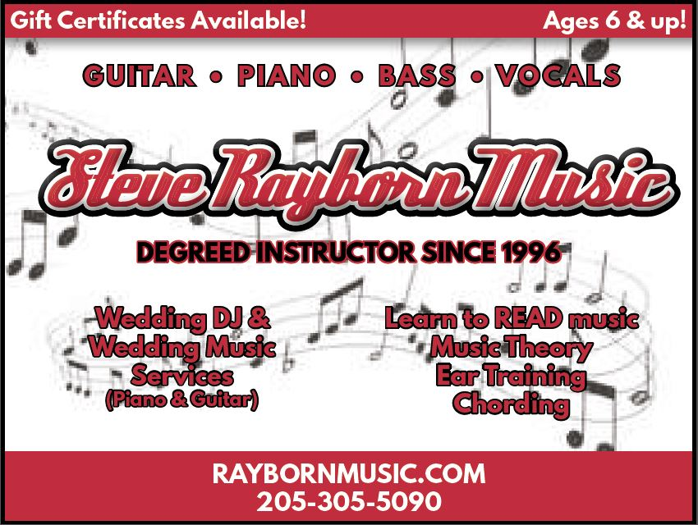

Wedding DJ Planning Packet

Hello! Thank you for downloading the worksheet. This is a very useful tool to help you communicate with DJ Steve to make sure your reception/event is full of fun and dance!
Thank You!
-DJ STEVE

To use this document:
- Modify the header that appears on every page to reflect your names and date. Be sure to keep this on every page.. it is best if every page is labeled.
- Customize the first page of the document to reflect your own schedule, names, phone numbers, and directions as needed to reflect your personal info.
- Modify the remaining sections of the checklist to reflect the music you want on your Big Day.
- Fill this out and give it to DJ Steve.
- If you have hired a planner please make sure they have a copy of this after completion!
Please use * symbol to mark the intended choices

DJ Event Info

Primary Contact Person and approach clause:

____________ – Any questions or problems about music or order of events should be directed to _____________, who knows the Bride and Groom’s wishes.(anyone who assumes this without dj’s knowledge will not be considered as dependable info)

Contact info:

Bride’s cell phone Bride’s assistant or planner
Groom’s cell phone 205-305-5090 DJ Steve

May we tag you or your wedding social media after your big day?

Instagram IDs :

Location :

Wedding Day Schedule:

Reception Events

These are to be led and announced by the DJ. Timing is up to DJ or planner to determine, but order of events should remain as listed.

- Guests eat
- Grand entrance- how would you like to be announced? (Mr. and Mrs…?)
- Bride and Groom’s first dance
- Bride dances with her father
- Groom dances with his mother
- Dance floor is open to all
- Cutting of the cake
- Best man’s toast
- Cake is served
- Bouquet and garter toss

Announcement of Bridal Party:

Bridal party members will enter as couples OR in three if uneven group.
Announce the names only (roles are provided in parenthesis for reference only).
(Bride and Groom) how do you want to be announced? Mr. And Mrs…

Bridal party list of names in order

DJ MUSIC INFO SHEET

Special Event Songs:

EVENT | SONG | ARTIST
Wedding prelude songs

Parents/grandparents seating song
Officiant/groom/
Wedding party
Bride entrance song
Special ceremony music

Recessional song (exit)
During Bridal Party announcements
Bride and Groom’s
First Dance/grand entrance
Bride dances with her father
Groom dances with his mother
Cake cutting song
Bouquet and garter toss songs

Bouquet and garter toss song choices -
Do you require songs to be shortened during the dances or full length?

Social hour/cocktail hour songs (if non provided we will assume light jazz and love song instrumentals)

Wedding music tip!
Do you know if your crowd is into dancing?
If so, you can send an rsvp email or include on your invitation to ask what song they will bring them to the dance floor ( ask for 3 songs).

Must play these songs:

These songs are special to the Bride and Groom and/or their family and friends, and must be played during the Open Dance portion of the reception.

SONG | ARTIST

Must NOT play these songs:

Under NO circumstances, even by guest request, should these songs be played:

SONG | ARTIST

DJ MUSIC INFO SHEET

General Music Styles we Like/Dislike:

MUSIC STYLE | WE LIKE IT | WE DISLIKE IT
Country
Pop
Oldies (50s and 60s)
Classic Rock (60s and 70s)
80s Rock / Pop
Rap
R&B
Heavy Metal
Classical
Latin
Folk
Jazz
Alternative Rock
Big Band
Christian
Disco
Hip Hop
Reggae
Punk
Techno

General Artists We Like/Dislike:
ARTIST / GROUP | WE LIKE THEM | WE DISLIKE

Please put an asterisk beside group dance songs you want in the reception

Cupid shuffle
Cha cha slide
Wobble

Photo Dash
( this allows you get to get a picture with everyone that attends the reception, and we do all the coordination! Best if done right after dinner. Check with your photographer before confirming this selection)
Musical chairs ( great for the bridal party and also helps encourage interaction )
Limbo(kids and young at heart)
Electric slide
The Conga line (gets the crowd up on the floor)
Anniversary dance( honors all married couples)
Shoe game (fun silly trivia game for newlyweds)
Freeze dance

General DJ Behavior and Our Preferences or other comments to help the dj:

